Software Requirement Specifications

UniEvent 360 – Smart Multi-Tiered Event Management & Digital Ticketing System


Submitted by
Ahmer Ali (S23BINFT1M01017)

Submitted to
Sir Wahaj Ali

Department of Information Technology
Faculty of Computing
The Islamia University of Bahawalpur

Meeting Details
Sr No | Details | Date | Supervisor Signature

Summary
This document defines the Software Requirements Specification (SRS) for UniEvent 360, a smart event management and digital ticketing system designed to digitize and centralize university event operations.
The system enables users to discover events, book tickets, and manage attendance using secure QR-based technology. It includes advanced features such as anti-clash scheduling, real-time ticket tracking, waitlist management, payment integration, and automated notifications.
Additionally, the system provides location-based navigation, allowing users to find event destinations through map integration and route guidance. The platform ensures efficiency, security, and transparency while eliminating manual processes.
Table of Contents
1. Introduction 5
1.1. Purpose 5
1.2. Scope 5
1.3. Product Perspective 6
1.4. User Characteristics 6
1.5. Similar Apps and Systems / Literature Review 6
1.6. Proposed Technologies 7
2. Requirements 9
2.1. Functional Requirements 9
2.2. Non-Functional Requirements 14
3. Use Cases and Flow of Processes 15
3.1. Use Case 1 — User Registration and Login 16
3.2. Use Case 2 — Create Event 19
3.3. Use Case 3 — Schedule Validation 21
3.4. Use Case 4 — Book Ticket 24
3.5. Use Case 5 — Join Waitlist 26
3.6. Use Case 6 — Process Payment 28
3.7. Use Case 7 —Scan Ticket 30
3.8. Use Case 8 — Receive Notifications 32
3.9. Use Case 9 — Manage Volunteers 34
4. References 36

Introduction

Traditional university event management systems rely heavily on manual processes, leading to issues such as scheduling conflicts, ticket fraud, and poor communication.
UniEvent 360 provides a fully digital solution by introducing a centralized platform where organizers can manage events efficiently, and users can easily discover, book, and attend events using secure digital tickets.
The system incorporates QR-based validation, real-time updates, automated notifications, and navigation support to enhance user experience and operational efficiency.
execution.
Purpose

The purpose of this Software Requirements Specification (SRS) document is to provide a complete and structured description of the UniEvent 360 system, including all functional and non-functional requirements. It serves as a reference for developers, supervisors, and stakeholders to understand system behavior and expected outcomes.
The main objective of UniEvent 360 is to digitize and streamline university event management by eliminating manual processes and introducing a secure, automated, and user-friendly platform.
This document specifically aims to:
- Define all core functionalities including event creation, ticket booking, QR validation, payments, and notifications
- Ensure implementation of advanced features such as anti-clash scheduling, real-time inventory, and waitlist systems
- Provide secure system operations using encrypted QR codes and role-based access control
- Support multiple user roles including users, organizers, volunteers, and administrators
- Enable users to locate event venues through integrated location-based navigation
- Ensure smooth communication through automated alerts and engagement features
- Maintain financial transparency through payment and refund mechanisms
- Provide a scalable and maintainable system architecture

Scope

System Includes:
- User registration and login
- Event creation and management
- Anti-clash scheduling system
- Digital ticket booking and QR validation
- Payment integration
- Waitlist system
- Notifications and reminders
- Volunteer management
- Analytics and admin dashboard

Out of Scope:
- Offline-only system (cloud required)
- Non-digital/manual ticketing

Product Perspective

UniEvent 360 is a standalone mobile application.
System Components:
- Flutter (Frontend)
- Firebase (Backend)
- Payment Gateway
- Google Maps API

User Characteristics

Three types of users will be interacting with this system:

User Role | Technical Level | Primary Interaction with the System
Student/User | Basic
  Discover & book events
Organizer | Intermediate | Manage events
Volunteer | Basic | Scan tickets
Admin | Advanced | Full control

Similar Apps and Systems / Literature Review

A few existing tools and research studies are related to what this project is trying to do. The table below compares them and explains what gap this system fills.

System / Study | Key Feature | Shortcoming Addressed by This Project
Eventbrite | Ticketing | Not university-specific
Facebook Events | Discovery | No secure entry
Manual System | Simple | No automation

Proposed Technologies

These are the technologies that will be used to build this system:

Layer | Technology | Role in the System
Frontend |  | Used to develop the mobile application interface, including all user screens such as event browsing, ticket booking, QR display, notifications, and profile management.
  Flutter (Dart)
Backend | Firebase Authentication | Handles secure user registration, login, and authentication for all system users including students, organizers, volunteers, and administrators.
Database | Cloud Firestore
  Stores all application data such as events, users, tickets, transactions, and system logs in a real-time and scalable database.
Real-Time Services | Firebase Realtime Database / Firestore | Enables real-time updates such as ticket availability, notifications, and live event status changes.
Storage | Firebase Storage | Stores user-related media such as event images, certificates, and other uploaded content.
Payment Gateway | azzCash / EasyPaisa / Bank APIs | Processes secure online payments for ticket purchases and manages financial transactions within the system.
Location Services | Google Maps API | Provides map integration, event location display, and navigation support from user location to event venue.
QR & Security | UUID-based QR Encryption | Generates unique encrypted QR codes for each ticket to prevent duplication and ensure secure entry validation.
Notifications | Firebase Cloud Messaging (FCM) | Sends automated alerts, reminders, and announcements to users regarding events and updates.
Development Tools
  Android Studio / VS Code
  Used for coding, testing, debugging, and managing the application development lifecycle.

Requirements

The main objective of the UniEvent 360 system is to provide a centralized and fully digital platform for managing university events efficiently and securely. The system enables users to discover events, book tickets, and access venues using QR-based validation, while organizers can manage events, monitor ticket sales, and control event operations.
The application is designed to support multiple user roles including students, organizers, volunteers, and administrators. Each user interacts with the system according to their permissions, while the system ensures secure data handling, real-time updates, and smooth communication between all participants.
The platform also incorporates advanced features such as anti-clash scheduling to prevent venue conflicts, real-time ticket inventory tracking, waitlist management for sold-out events, and automated notifications. Additionally, users can easily locate event venues through integrated location-based navigation, enhancing accessibility and convenience.
Overall, the system focuses on automation, security, transparency, and scalability to provide a professional and modern event management experience.

2.1. Functional Requirements

The functional requirements below describe all the operations and features that the system must perform. Each requirement defines a specific functionality of the system along with its purpose, users, input, and expected output.

2.1.1 FR001 – User Authentication
- Name: FR001
- Purpose: To allow users to securely register and log in to the system.
- User(s): User, Organizer, Volunteer, Admin
Input:
- Full Name
- Email Address
- Password
Output:
- User account created and access granted

2.1.2 FR002 – Event Creation & Management
- Name: FR002
- Purpose: To allow organizers to create, update, and manage events.
- User(s): Organizer
Input:
- Event title, date, time, venue, description
Output:
- Event successfully created and displayed

2.1.3 FR003 – Anti-Clash Scheduling
- Name: FR003
- Purpose: To prevent scheduling conflicts for venues.
- User(s): Organizer
Input:
- Event date, time, venue
Output:
- Conflict validation result

2.1.4 FR004 – Event Categorization
- Name: FR004
- Purpose: To classify events into different levels.
- User(s): Organizer
Input:
- Event category (University / Faculty / Department)
Output:
- Categorized event

2.1.5 FR005 – Ticket Booking System
- Name: FR005
- Purpose: To allow users to book event tickets.
- User(s): User
Input:
- Selected event
Output:
- Ticket issued

2.1.6 FR006 – Dual Pricing System
- Name: FR006
- Purpose: To apply different pricing for students and outsiders.
- User(s): System
Input:
- User type
Output:
- Price applied

2.1.7 FR007 – Real-Time Ticket Inventory
- Name: FR007
- Purpose: To track available tickets in real time.
- User(s): User, Organizer
Input:
- Ticket data
Output:
- Updated ticket count

2.1.8 FR008 – Waitlist System
- Name: FR008
- Purpose: To manage users when tickets are sold out.
- User(s): User
Input:
- Waitlist request
Output:
- User added to queue

2.1.9 FR009 – Payment Integration
- Name: FR009
- Purpose: To process secure payments.
- User(s): User
Input:
- Payment details
Output:
- Payment confirmation

2.1.10 FR010 – Refund Management
- Name: FR010
- Purpose: To manage ticket refunds.
- User(s): Organizer
Input:
- Refund request
Output:
- Refund processed

2.1.11 FR011 – QR-Based Ticket Validation
- Name: FR011
- Purpose: To verify tickets securely using QR codes.
- User(s): Volunteer
Input:
- QR code
Output:
- Ticket status verified

2.1.12 FR012 – Offline Scanning Mode
- Name: FR012
- Purpose: To allow ticket scanning without internet.
- User(s): Volunteer
Input:
- QR code
Output:
- Data stored and synced later

2.1.13 FR013 – Notification System
- Name: FR013
- Purpose: To send alerts and reminders.
- User(s): System
Input:
- Event data
Output:
- Notification delivered

2.1.14 FR014 – Volunteer Management
- Name: FR014
- Purpose: To manage volunteer activities.
- User(s): Organizer
Input:
- Volunteer data
Output:
- Performance tracking

2.1.15 FR015 – Certificate Generation
- Name: FR015
- Purpose: To generate participation certificates.
- User(s): System
Input:
- Attendance data
Output:
- Certificate generated

2.1.16 FR016 – Social Sharing & Engagement
- Name: FR016
- Purpose: To allow event sharing and interaction.
- User(s): User
Input:
- Event data
Output:
- Event shared

2.1.17 FR017 – Admin Panel
- Name: FR017
- Purpose: To manage system operations.
- User(s): Admin
Input:
- System data
Output:
- System controlled

2.1.18 FR018 – Event Location & Navigation
- Name: FR018
- Purpose: To allow users to view event locations and navigate using maps.
- User(s): User
Input:
- Event location
Output:
- Navigation route displayed

2.2. Non-Functional Requirements

Non-functional requirements define the quality standards and constraints under which the UniEvent 360 system must operate. These requirements focus on system performance, usability, security, reliability, and overall efficiency rather than specific functionalities.

ID | Quality Attribute | Requirement Description
NFR001 | Performance | The system should respond to user actions within 2–3 seconds under normal conditions, including event loading, ticket booking, and QR validation.
NFR002 | Usability
  The application interface must be simple, intuitive, and user-friendly so that even first-time users can easily navigate and perform actions without external guidance.
NFR003 | Security | User data, payment information, and QR tickets must be securely stored and transmitted using encryption and secure authentication mechanisms.
NFR004 | Reliability | The system should operate continuously without crashes and must handle errors gracefully without data loss.
NFR005 | Scalability
  The system must support a large number of users, events, and transactions without performance degradation.
NFR006 | Availability | The application should be available 24/7 with minimal downtime, ensuring continuous access for users and organizers.
NFR007 | Maintainability | The system should be modular and well-structured so that updates, bug fixes, and new features can be implemented easily.
NFR008 | Portability | The application should run smoothly on different Android devices with varying screen sizes and hardware specifications.
NFR009 | Data Consistency
  All system data such as tickets, payments, and attendance records must remain accurate and synchronized across all users and devices.
NFR010 | Free Access Constraint | Each QR code must be unique, encrypted, and usable only once to prevent duplication and fraud.
NFR011 | Location Accuracy | The system must provide accurate location data and navigation routes to ensure users can reach event venues without confusion.

Use Cases and Flow of Processes

Use cases describe how different users interact with the UniEvent 360 system to perform specific tasks. The main actors in the system include User (Student/Outsider), Organizer, Volunteer, and Administrator. The system also performs automated operations such as ticket validation, notifications, and data synchronization.
The table below provides an overview of all use cases and their corresponding functional requirements.

Use Case | Name | Actor(s) | Requirement(s)
UC001 | User Registration and Login |  | FR001
  All Users
UC002 | Create Event | Organizer | FR002
UC003 | Schedule Validation | Organizer | FR003,
UC004 |  | User | FR005–FR007
  Book Ticket
UC005 | Join Waitlist | User | FR008
UC006 | Process Payment | User | FR009
UC007 |  | Volunteer | FR011–FR012
  Scan Ticket
UC008 | Receive Notifications | System/User | FR0013
UC009 | Manage Volunteers | Organizer | FR014
UC0010 |  | System | FR015
  Generate Certificates
UC011 | Admin Management | Admin | FR017
UC012 | Event Location & Navigation | User | FR018

3.1. Use Case 1 — User Registration and Login

ID | UC001
Name | User Registration and Login
Description | Users create an account and log in to access system features
Requirement(s) | FR001
Actor(s) | User, Organizer, Volunteer, Admin
Pre-condition | User has access to the application
Post-condition | User successfully logged in
Basic Flow | Basic Flow  - User opens application  - User enters name, email, password  - System validates input  - Account is created  - User logged in  Exceptions  - Invalid input → Error message  - Network issue → Retry option

Diagrams
The activity diagram below illustrates the step-by-step process of user registration and login. It shows how the user enters their credentials, how the system validates the input, and how access is granted upon successful authentication.
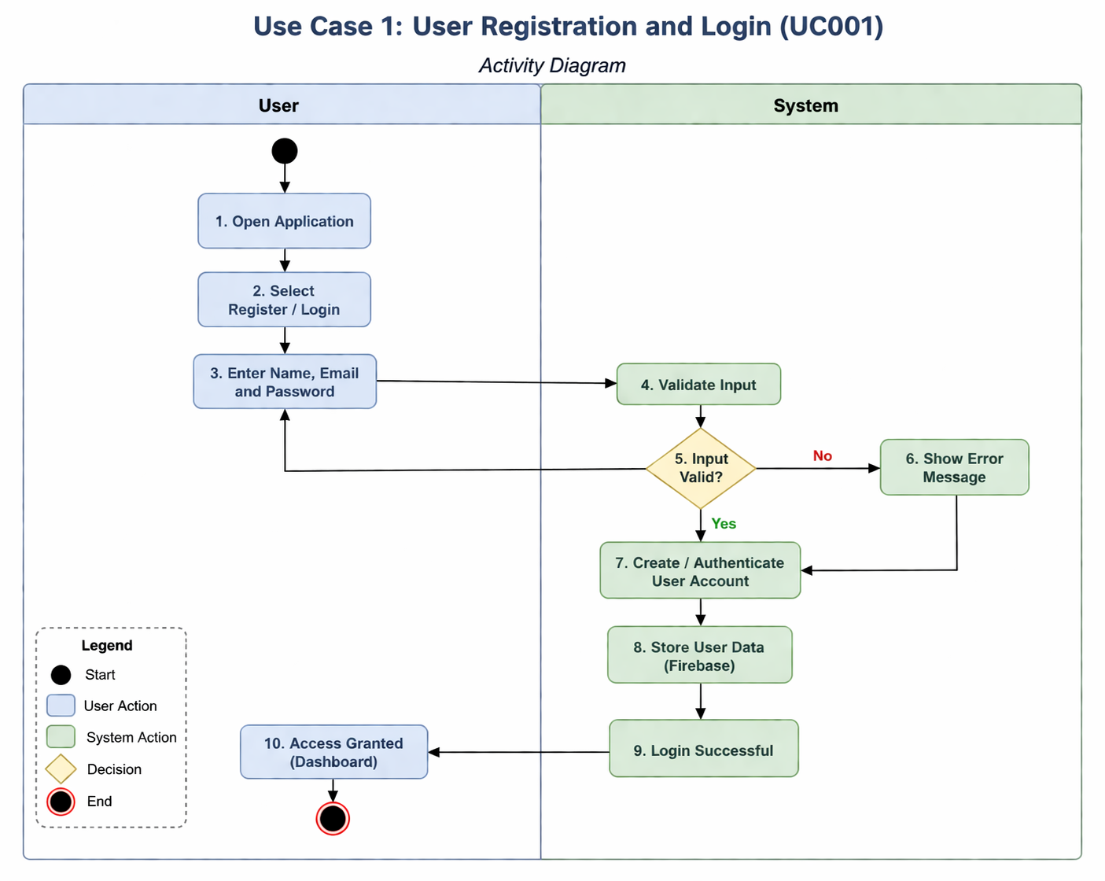

3.2. Use Case 2 — Create Event

ID | UC002
Name | Create Event
Description | This use case allows an organizer to create a new event in the system by providing complete event details such as title, description, date, time, venue, category, ticket pricing, and capacity. The system validates the input, checks for scheduling conflicts, and stores the event in the database. Once created, the event becomes visible to users for booking
Requirement(s) | FR002
Actor(s) | Organizer
Precondition | The organizer must be logged into the application.
Postcondition | The event is successfully created and displayed on the organizer dashboard and available to users.
Basic Flow | Basic Flow  - Organizer selects “Create Event” from dashboard  - System displays event creation form  - Organizer enters event details (title, description, date, time, venue, category, ticket price, capacity, image)  - Organizer submits the form  - System validates the entered data  - System checks for scheduling conflicts (venue and time)  - If valid, system stores the event in database  - System confirms successful event creation  - Event is displayed on dashboard and becomes visible to users  Alternative Flow  - Organizer updates or edits event details before submission  - System updates form accordingly  Exceptions  - If required fields are empty → System shows validation error  - If venue and time conflict occurs → System prevents event creation  - If image upload fails → System allows retry or skip  - If network error occurs → Data is not saved

Diagrams
The activity diagram below illustrates the process of creating an event in the system. It shows how the organizer enters event details, how the system validates the data, checks for scheduling conflicts, and stores the event in the database. Once the event is successfully created, it becomes visible on the organizer dashboard and available to users.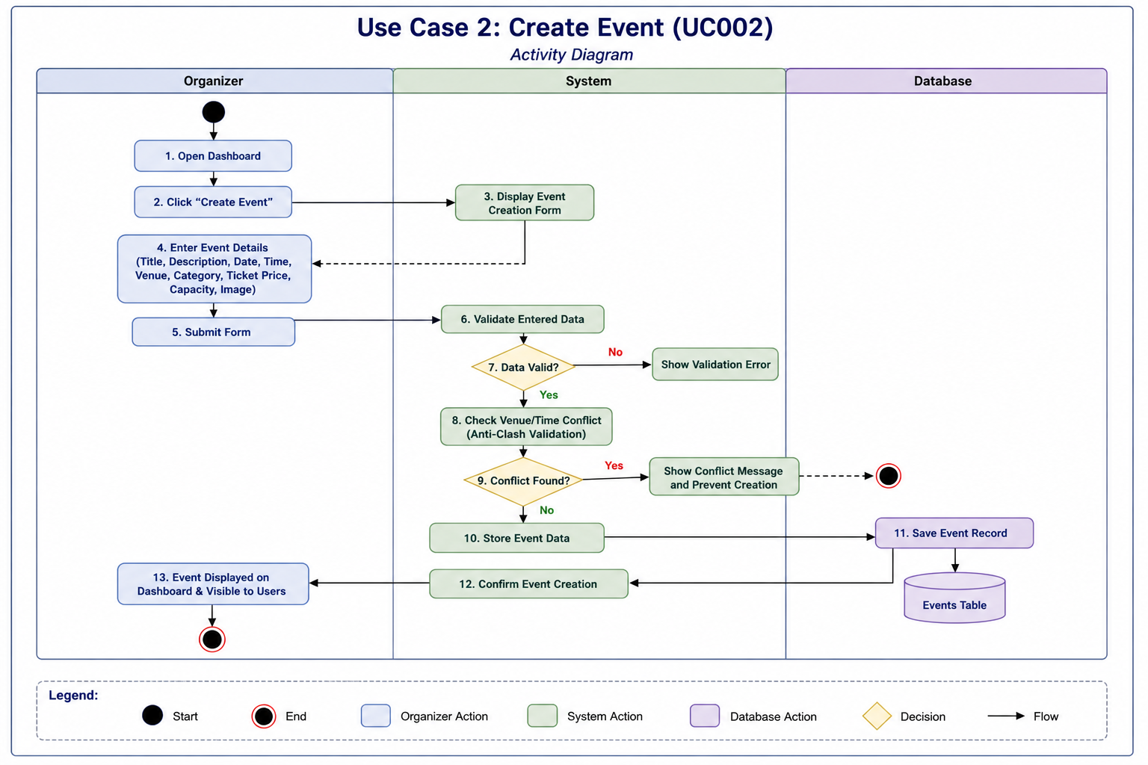

3.3. Use Case 3 — Schedule Validation
ID | UC003
Name | Schedule Validation
Description | This use case ensures that an event cannot be scheduled if the selected venue is already booked at the same date and time. The system performs real-time validation to detect conflicts and prevents overlapping events, ensuring efficient resource utilization and avoiding scheduling issues.
Requirement(s) | FR003
Actor(s) | Organizer
Precondition | • Organizer must be logged into the system  • Organizer is creating or updating an event
Postcondition
  Event is either approved (no conflict) or rejected (conflict detected)
Basic Flow | Basic Flow  - Organizer enters event date, time, and venue  - System receives scheduling data  - System checks existing events in database  - System compares venue, date, and time  - If no conflict exists → validation successful  - System allows event creation to continue  Alternative Flow  - Organizer modifies event schedule before submission  - System re-validates updated data  Exceptions  - If venue is already booked at same time → System shows conflict message  - If invalid date/time entered → System shows validation error

Diagrams
The activity diagram below illustrates the process of schedule validation. It shows how the system checks event details against existing records, detects conflicts based on venue and time, and either allows or prevents event creation accordingly.
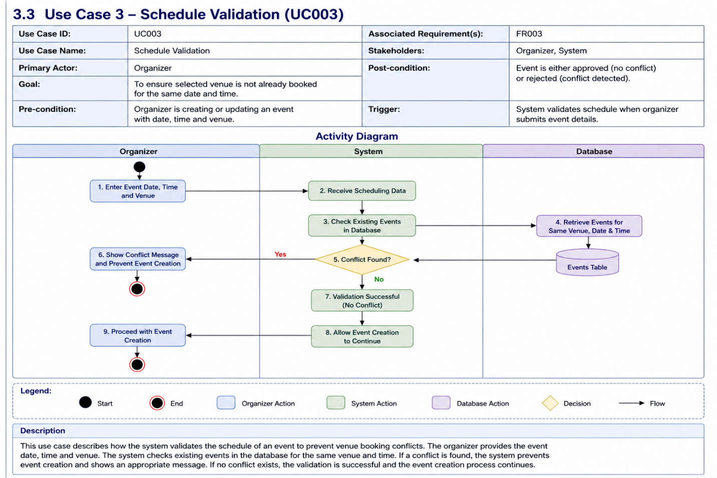

3.4. Use Case 4 — Book Ticket

ID | UC004
Name | Book Ticket
Description | This use case allows a user to select an event and book tickets based on availability. The system displays event details, checks ticket inventory in real time, applies pricing rules, and reserves the selected tickets.
Requirement(s) | FR005, FR006, FR007
Actor(s) | User (Student / Outsider)
Precondition | • User must be logged into the system  • Event must be available
Postcondition | Communication (chat, image, or screen sharing) is successfully completed.
Basic Flow | Basic Flow  - User opens event listing  - User selects an event  - System displays event details  - User selects number of tickets  - System checks ticket availability  - System applies pricing (student / outsider)  - If tickets available → system reserves tickets  - System updates ticket inventory  - User proceeds to payment (if required)  Alternative Flow  - User changes ticket quantity  - System updates availability and pricing dynamically  Exceptions  - If tickets are sold out → System suggests waitlist  - If requested quantity exceeds availability → Error shown  - If pricing data missing → System shows error  - If network issue occurs → Booking not processed

Diagrams
The activity diagram below illustrates the ticket booking process. It shows how the user selects an event, how the system checks ticket availability and pricing, and how tickets are reserved before proceeding to payment.
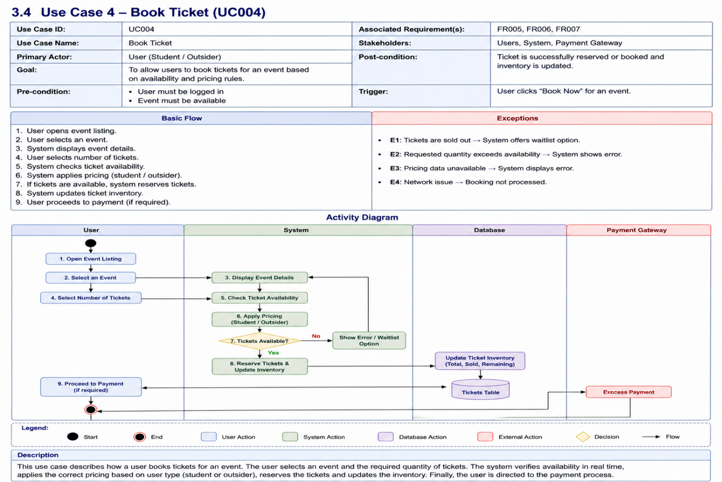

3.5. Use Case 5 — Join Waitlist

ID | UC005
Name | Join Waitlist
Description | This use case allows users to join a waitlist when tickets for an event are sold out. The system automatically queues users and allocates tickets if they become available due to cancellation or increased capacity.
Requirement(s) | FR008
Actor(s) | User (Student / Outsider)
Precondition | • User must be logged into the system  • Event tickets are sold out
Postcondition
  • User is successfully added to the waitlist
  • User is notified if a ticket becomes available
Basic Flow | Basic Flow  - User selects an event  - System shows that tickets are sold out  - User clicks “Join Waitlist”  - System records user request  - System adds user to waitlist queue  - System confirms waitlist registration  Alternative Flow  - User cancels waitlist request  - System removes user from queue  Exceptions  - If user already in waitlist → System shows message  - If waitlist limit reached → System denies request  - If network issue occurs → Request not processed

Diagrams
he activity diagram below illustrates the waitlist process. It shows how the system adds users to a queue when tickets are unavailable and manages ticket allocation when availability changes.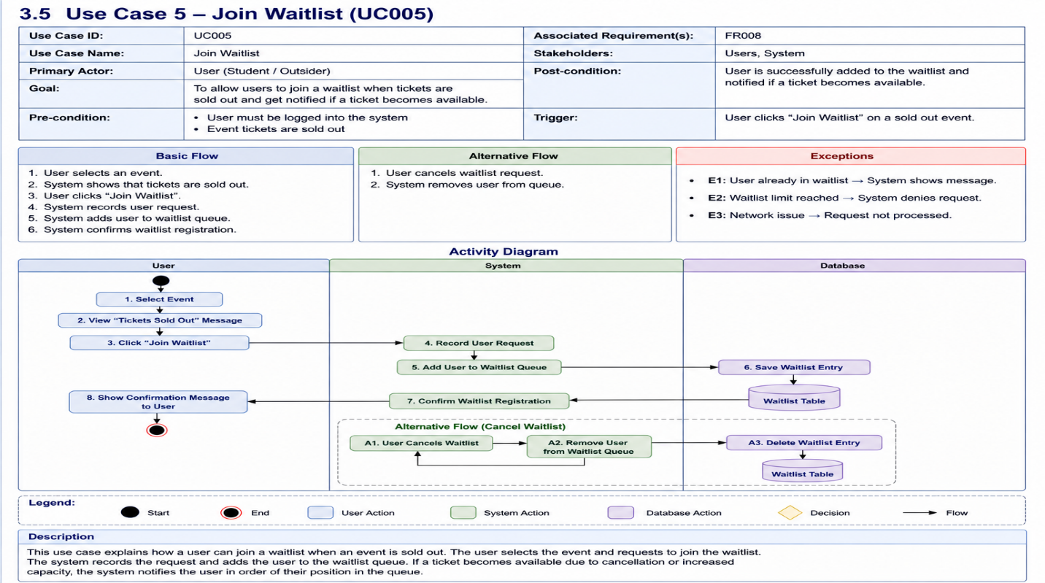

3.6. Use Case 6 — Process Payment

ID | UC006
Name | Process Payment
Description | This use case allows users to complete the payment for booked tickets using supported payment methods such as JazzCash, EasyPaisa, or bank cards. The system processes the transaction securely and confirms the payment status
Requirement(s) | FR009
Actor(s) | User (Student / Outsider)
Precondition | • User must have selected tickets  • Payment option must be available
Postcondition | • Payment is successfully processed  • Ticket booking is confirmed
Basic Flow | Basic Flow  - User proceeds to payment  - System displays payment options  - User selects payment method  - User enters payment details  - System sends request to payment gateway  - Payment gateway processes transaction  - System receives payment response  - If successful → booking confirmed  - System updates transaction records  Alternative Flow  - User changes payment method  - System updates payment process  Exceptions  - Payment failed → System shows error  - Invalid payment details → Retry required  - Payment gateway timeout → Transaction pending  - Network issue → Payment not processed

Diagrams
The activity diagram below illustrates the payment process. It shows how the user selects a payment method, how the system interacts with the payment gateway, and how the transaction is processed and confirmed. 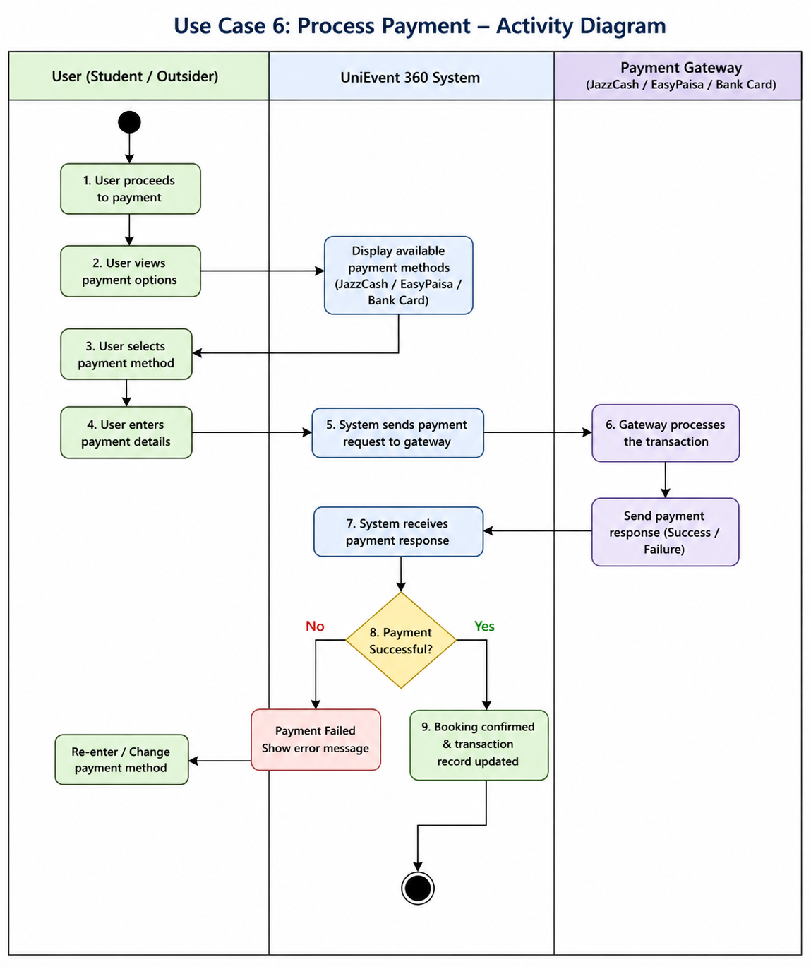

3.7. Use Case 7 — Scan Ticket

ID | UC007
Name | Scan Ticket
Description | This use case allows volunteers to scan QR codes on user tickets at the event venue to verify entry. The system checks the ticket’s validity, ensures it has not been used before, and marks it as “Used” after successful verification to prevent fraud.
Requirement(s) | FR011, FR012
Actor(s) | Volunteer
Pre-condition
  • Volunteer must be logged into the system
  • User must have a valid QR ticket
Post-condition | • Ticket is verified successfully  • Ticket status updated to “Used”  • User is granted entry
Basic Flow | Basic Flow  - Volunteer opens scanning feature  - Volunteer scans QR code  - System reads QR data  - System checks ticket validity  - System verifies ticket status (used / unused)  - If valid and unused → ticket accepted  - System marks ticket as “Used”  - Entry is granted  Alternative Flow  - System operates in offline mode  - Data stored locally  - Data synced when internet available  Exceptions  - Invalid QR code → Access denied  - Ticket already used → Entry rejected  - QR unreadable → Retry scan  - System offline (sync pending) → Temporary validation

Diagrams
The activity diagram below illustrates the ticket scanning process. It shows how the volunteer scans the QR code, how the system verifies ticket authenticity and usage status, and how access is granted or denied accordingly. 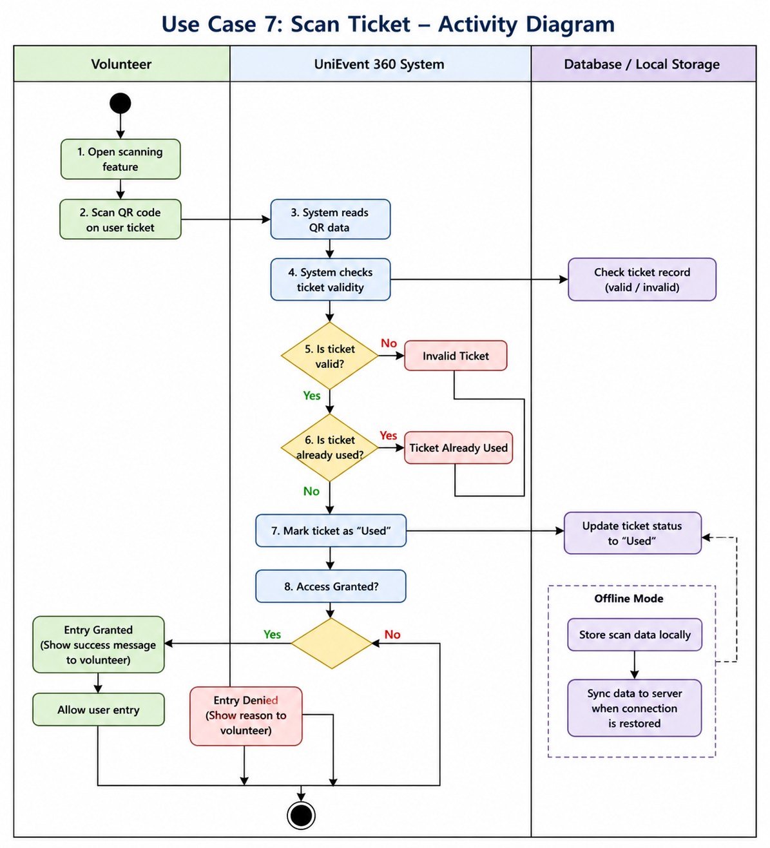

3.8. Use Case 8 — Receive Notifications

ID | UC008
Name | Receive Notifications
Description | This use case allows the system to send automated notifications to users regarding event updates, reminders, schedule changes, and announcements. Notifications ensure users stay informed about upcoming events and important changes.
Requirement(s) | FR013
Actor(s)
  System, User
Precondition | • User must be registered in the system  • Notifications must be enabled
Postcondition
  User receives notification successfully
Basic Flow | Basic Flow  - Event update or trigger occurs  - System prepares notification content  - System identifies target users  - System sends notification  - User receives notification on device  Alternative Flow  - User disables notifications  - System stops sending notifications  Exceptions  - Notification delivery failure → Retry  - Invalid user token → Notification not sent  - Network issue → Delay in delivery

Diagrams
The activity diagram below illustrates the notification process. It shows how the system generates notifications based on triggers and delivers them to users in real time.
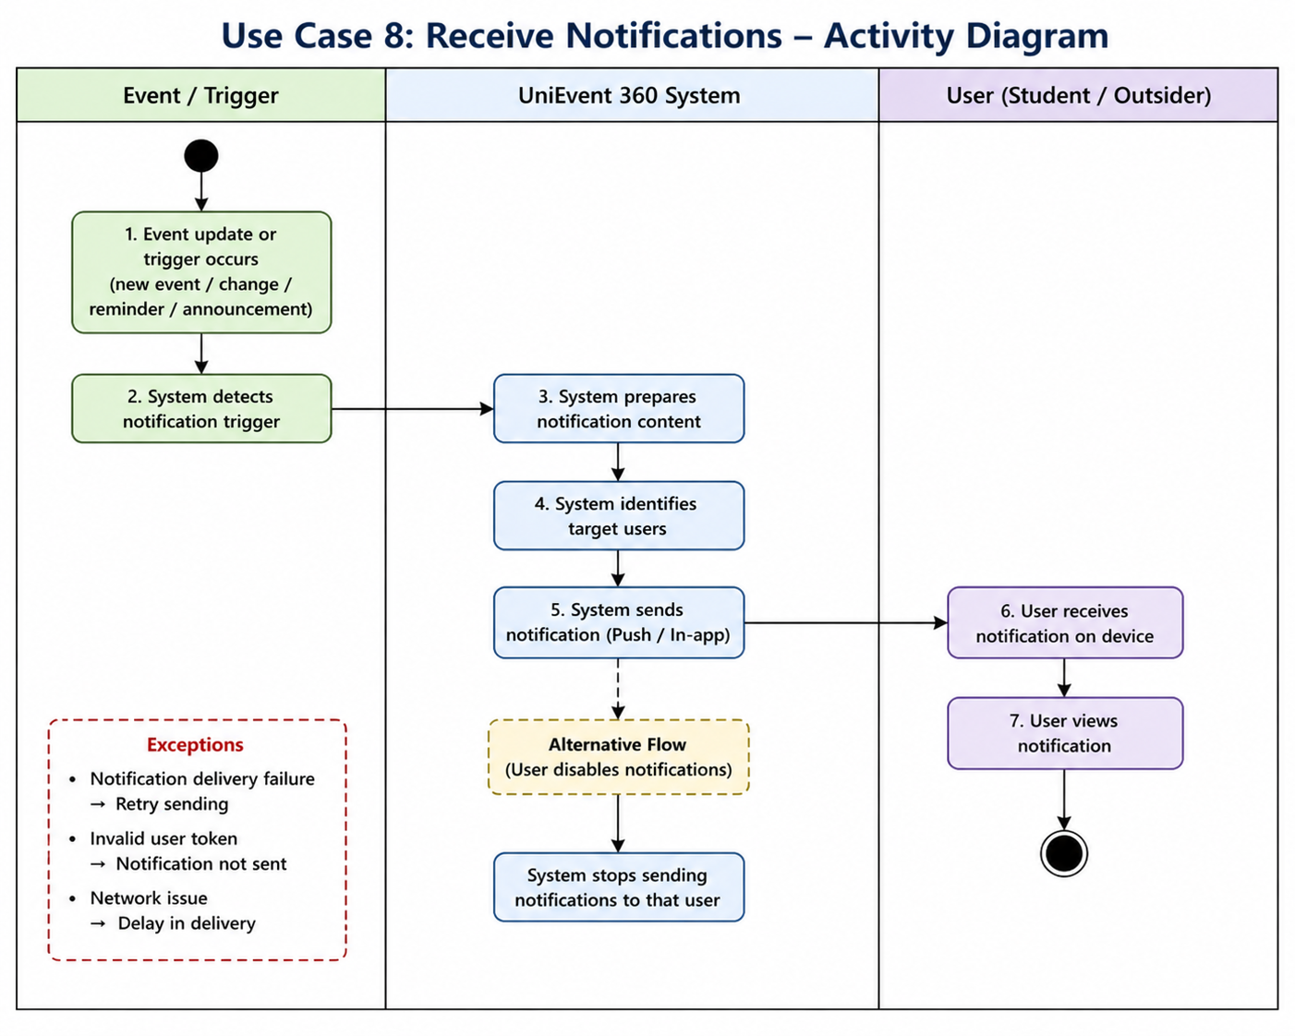

3.9. Use Case 9 — Manage Volunteers
ID | UC009
Name | Manage Volunteers
Description | This use case allows organizers to assign, monitor, and manage volunteers for event operations such as ticket scanning and attendance tracking. The system records volunteer activity including check-in and check-out times for performance evaluation.
Requirement(s) | FR014
Actor(s) | Organizer
Precondition | • Organizer must be logged into the system  • Event must be created
Postcondition | • Volunteers are assigned and tracked successfully  • Volunteer performance data is stored
Basic Flow | Basic Flow  - Organizer opens event dashboard  - Organizer selects “Manage Volunteers”  - System displays volunteer list  - Organizer assigns volunteers to event  - System records assigned volunteers  - During event, system tracks volunteer activity (check-in/check-out)  - System stores performance data  Alternative Flow  - Organizer updates or removes volunteers  - System updates volunteer assignments  Exceptions  - Volunteer not available → Assignment fails  - Duplicate assignment → System shows error  - Network issue → Data not updated

Diagrams
The activity diagram below illustrates the process of managing volunteers. It shows how the organizer assigns volunteers, how the system tracks their activity, and how performance data is stored.

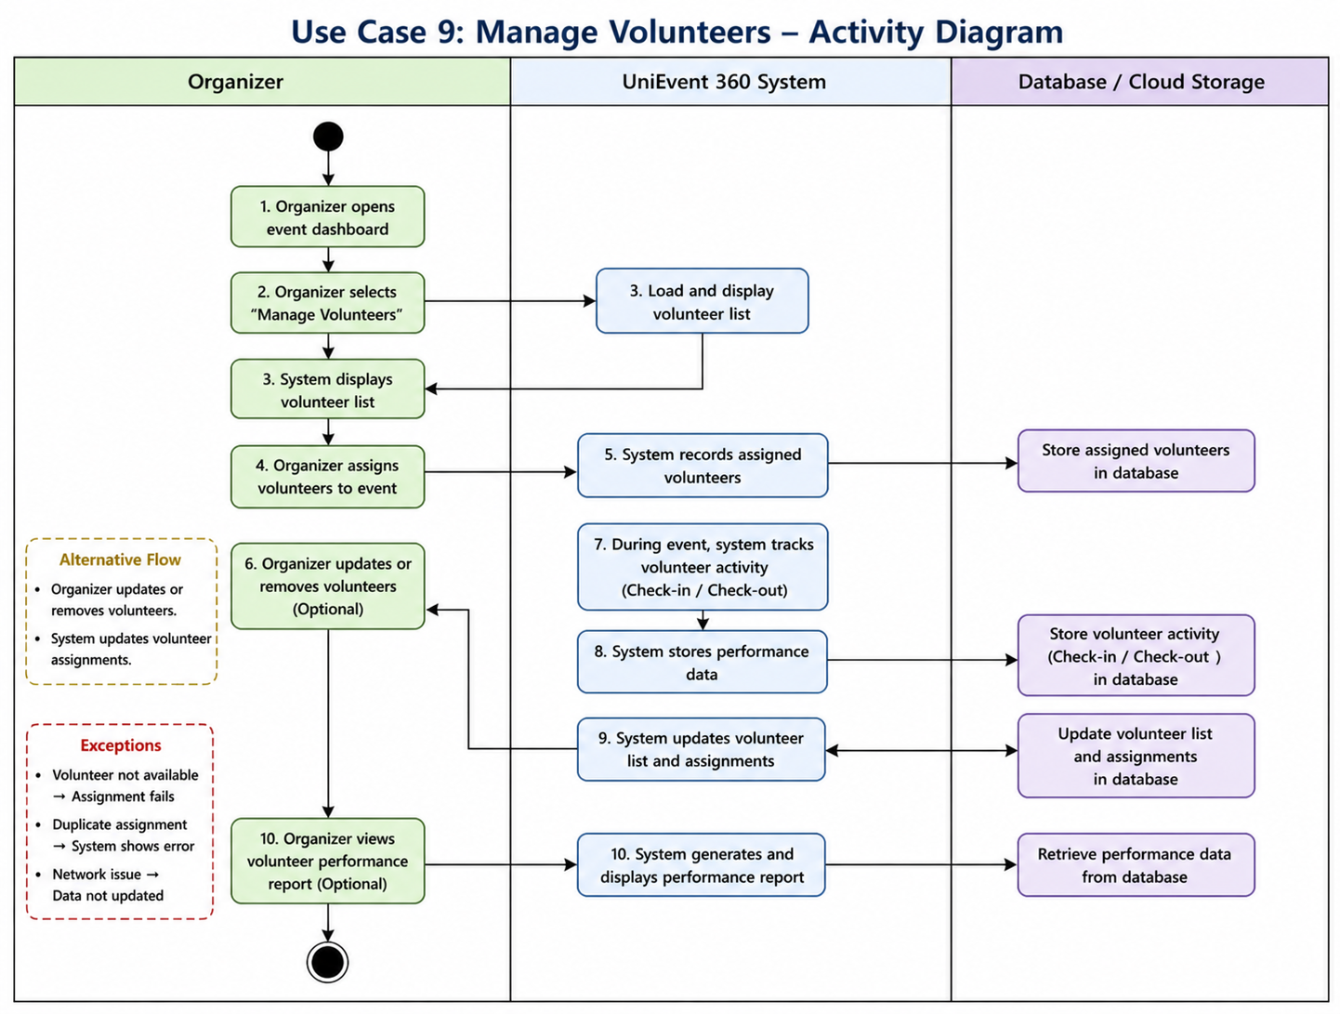

3.10. Use Case 10 — Generate Certificates
ID | UC0010
Name | Generate Certificates
Description | This use case allows the system to automatically generate and distribute digital certificates to users who successfully attend an event. The system verifies attendance based on QR scan records and generates certificates in PDF format for eligible users.
Requirement(s) | FR015
Actor(s) | System
Precondition | • Event must be completed  • User attendance must be verified through QR scanning
Postcondition | Certificate is generated and sent to eligible users
Basic Flow | Basic Flow  - Event is completed  - System retrieves attendance data  - System verifies users who attended event  - System generates certificate for eligible users  - System sends certificate to users  Alternative Flow  - Organizer manually triggers certificate generation  - System processes request  Exceptions  - No attendance data → Certificate not generated  - Invalid user data → Error occurs  - PDF generation failure → Retry  - Network issue → Delay in delivery

Diagrams
The activity diagram below illustrates the certificate generation process. It shows how the system verifies attendance and generates certificates for eligible users before distributing them.

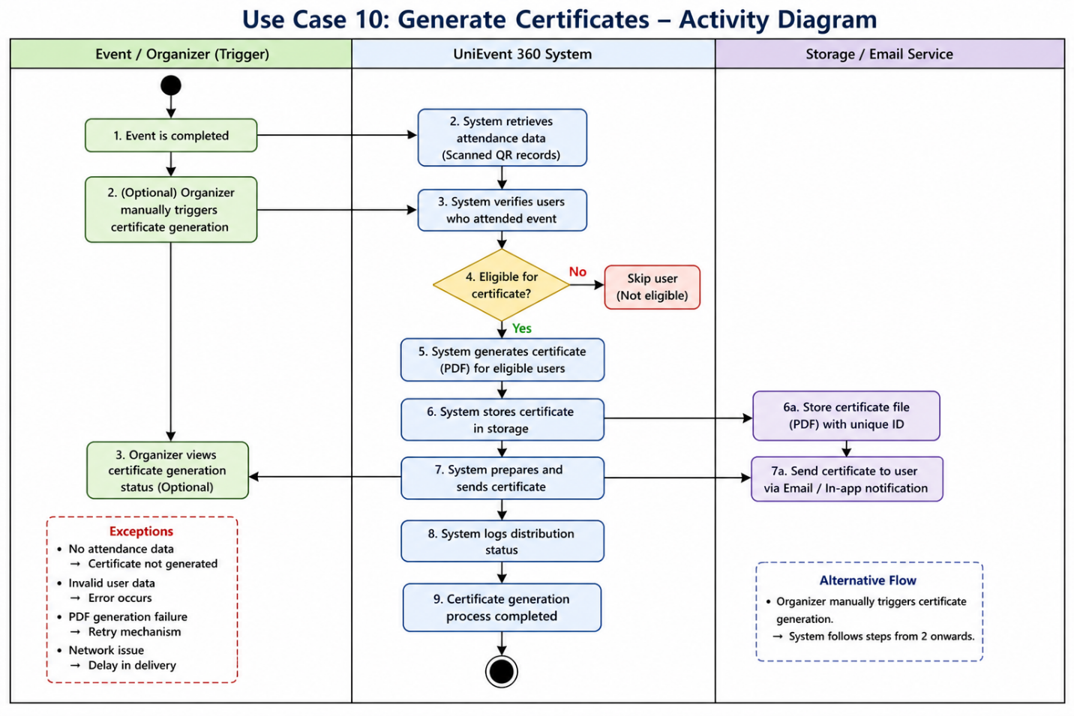

3.11. Use Case 11 — Admin System Management
ID | UC0010
Name | Admin System Management
Description | This use case allows the administrator to manage the overall system, including monitoring events, managing users, and ensuring smooth operation of the platform. The admin has full control over system activities and can perform actions such as viewing reports, managing user accounts, and overseeing platform performance.
Requirement(s) | FR017
Actor(s) | Admin
Precondition | Admin must be logged into the system with administrative privileges
Postcondition | • System data is updated according to admin actions  • Platform is monitored and controlled effectively
Basic Flow | Basic Flow  User Management:  - Admin logs into admin panel  - Admin views list of users  - Admin selects a user  - Admin performs action (view / edit / deactivate / delete)  - System updates user data  System Monitoring:  - Admin views system dashboard  - Admin monitors events and activities  - Admin checks reports and analytics  Alternative Flow  - Admin searches for a specific user  - System filters and displays results  Exceptions  - Invalid admin action → System shows error  - Unauthorized access → Access denied  - Network issue → Data not updated

Diagrams
The activity diagram below illustrates the process of admin system management. It shows how the administrator manages users, monitors system activities, and performs administrative actions to control the platform.

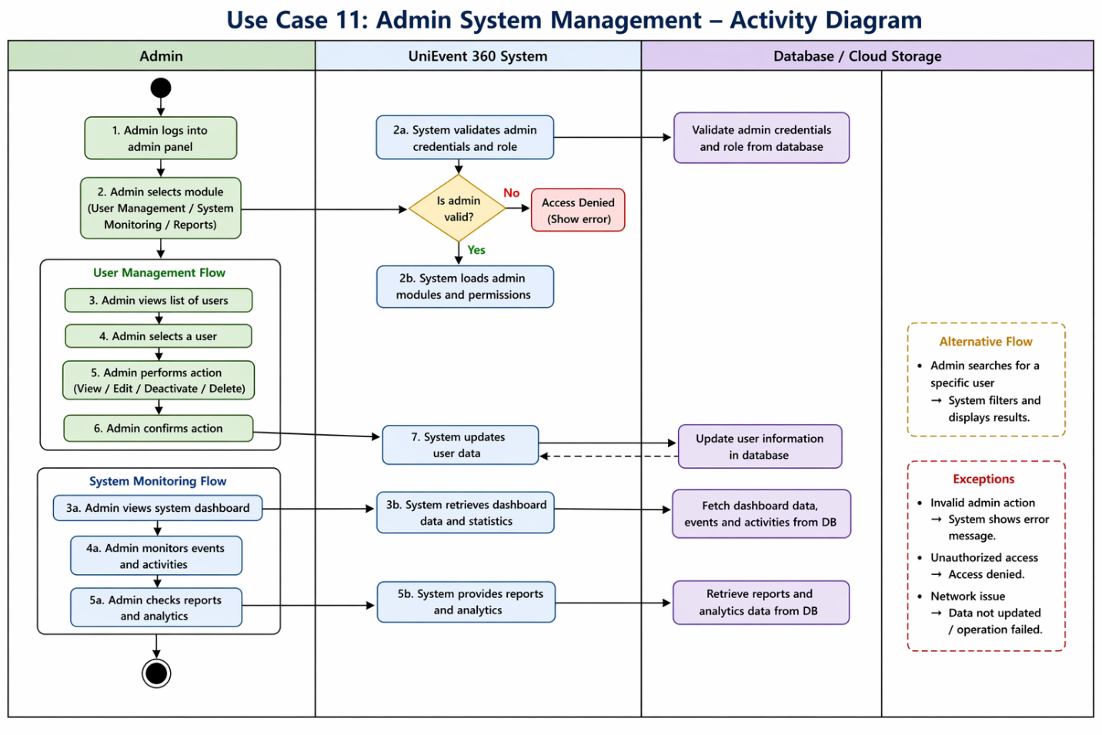

3.12. Use Case 12 — Event Location & Navigation
ID | UC0010
Name | Event Location & Navigation
Description | This use case allows users to view the exact location of an event on a map and navigate to the venue using location-based services. The system uses map integration to display the event location and provides directions from the user’s current location to the event destination.
Requirement(s) | FR018
Actor(s) | User (Student / Outsider)
Precondition | • User must be logged into the system  • Event must have a valid location  • Device location (GPS) must be enabled
Postcondition | • • Event location is displayed on map  • Navigation route is provided to the user
Basic Flow | Basic Flow  - User opens event details  - User selects “View Location”  - System loads map interface  - System displays event location marker  - System detects user’s current location  - User selects “Get Directions”  - System calculates route  - Navigation path is displayed  Alternative Flow  - User opens map without enabling GPS  - System shows event location only (no navigation)  Exceptions  - Location not available → System shows error  - GPS disabled → Prompt user to enable location  - Map loading failure → Retry option  - Network issue → Map not loaded

Diagrams
The activity diagram below illustrates the process of event location and navigation. It shows how the system displays the event location on a map, detects the user’s current location, and provides navigation directions to reach the event venue.
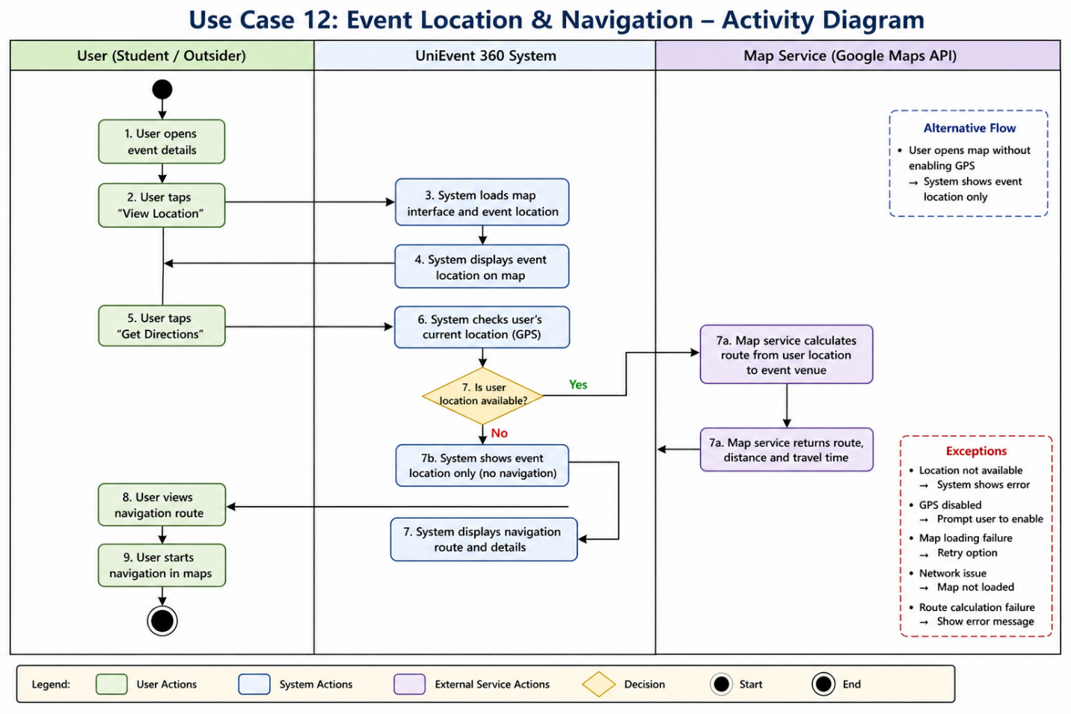
4. References
[1] Google, Firebase Documentation, 2025. [Online]. Available: https://firebase.google.com/docs
[2] Flutter, Flutter Documentation, 2025. [Online]. Available: https://docs.flutter.dev
[3] Google, Google Maps Platform Documentation, 2025. [Online]. Available: https://developers.google.com/maps
[4] IEEE, IEEE Recommended Practice for Software Requirements Specifications, IEEE Std 830-1998
[5] Pressman, R. S., Software Engineering: A Practitioner’s Approach, 8th Edition, McGraw-Hill, 2019
[6] Sommerville, I., Software Engineering, 10th Edition, Pearson, 2016
[7] UniEvent 360 Project Proposal

